APPROACHING THE LABOUR MARKET IN THE EUROPEAN EDUCATIONAL ENVIRONMENT. RECOMMENDATIONS, TRENDS AND COMPARATIVE EXAMPLES IDENTIFIED IN LAJOST RESEARCH PROJECT

LAURA MALIŢA, CĂTĂLIN MARTIN

Abstract
The current labour market context has changed much from what was known 2-3 years ago. Thus, technological changes which affect the global society and the global economic crisis have generated irreversible transformations of the labour market and changed the conduct of the actors involved in this process. In this context, the employers, the current employees and candidates for a particular job act differently than few years ago. From the perspective of employers, they are confronted primarily with the global economic recession which generates more possible candidates for a particular job. In parallel, the number of university graduates has increased considerably, which led an increasing number of potential candidates for a particular job. Moreover, thanks to globalization induced by the information society, candidates for a particular job may be more widespread geographically. Therefore, the employer will have to make a more rigorous selection, even using the new media and technology environments that exist, such as online social networks, services, which provide information about jobs, how to access them more successfully, etc. The candidates for a particular job must be aware that there is a more stiffer and a more varied competition (at least in terms of geographical location). Moreover, the economic crisis affects all of us, but maybe mostly those who are looking for a job according to their education and gained qualifications . These persons shall use any possible means, any contacts (online or offline) that can contribute to their success. Considering all that was mentioned above, this paper presents the results of a research conducted in six European countries participating in a research project. So, in this project it is intended to observe how the employers analyse the candidates’ portfolios (digital or traditional) , what would be helpful for both employers and candidates to know and use. Moreover, the participation of several partners in the research project from different countries can help to observe and compare the differences and particularities highlighted and taken into consideration in the European labour market.
Keywords: labour market, job, information society, ePortfolios, L@jost

- Introduction
Current generations of students are those who know about the existence of Google ever since they entered the school. For them, Google is omnipresent, being a kind of second nature for all people who want to search or to get informed about something. For these generations of students, which have been assigned distinct labels: millennial, digital natives, or Generation Y, educators have to adapt and design new programs and educational offerings. Moreover, teachers should change the way they see the integration of new technologies in everyday life, both for them and their students, in order to understand better the educational needs of students who apparently managed to combine in a very ingenious and natural way the use of new technologies with almost all current activities.
Even if founded opinions are based on the fact that their excessive use can generate the loss of social skills for the next generation, they have no time to reflect upon the knowledge and skills acquired, etc, however, we must understand that using these technologies has become a kind of second nature to them regarding the discussions they have with members of their entourage, building of learning communities, etc.
More importantly, the entire social, economic, information context has changed enormously from what everyone knew 2-3 years ago. If we refer only to the labour market, technological changes affecting global society, and also the global economic crisis led to irreversible changes in the labour market and actors’ behaviour involved in this process. In this context, both employers, current employees and job candidates behave differently compared to the same action that took place several years ago.
From the perspective of employers, they are confronted primarily with global economic recession which has, inter alia, the immediate effect of increasing the number of possible candidates for a particular job. In parallel, the number of university graduates has increased considerably, and more than that, thanks to globalization which was induced by information society, candidates for a particular job may be more geographically widespread. Therefore the employer will be able to make a more rigorous selection, even using the new tools and technological environments that exist, such as online social networks which provide information about jobs, how to access them more successfully, etc.
From the job candidates’ perspective, they must be aware that they face a more stiffer and varied competition (at least in terms of geographic location). Moreover, the economic crisis affects each of us, but maybe mostly the people looking for a job according to their education and acquired skills. Therefore, such persons should use all possible means, all contacts (online or offline) that can contribute to such success.
Considering all mentioned above, this paper presents the key skills and competences required throughout the career. Moreover, here will be presented in a non-exhaustive manner the results of a research conducted in six European countries participating in a joint research project. This project will try to observe how the employers analyse the candidates’ portfolios (digital or traditional), what would be helpful for both employers and candidates to know and use. The participation of several partners from different countries in the research project can be observed, and in a comparative manner, what differences and particularities are highlighted on the European labour market.

- Student in Web 2.0 era

As we mentioned before, the current generation of students is more different than the previous one. Thus, these students are digital natives, using current technology as their second nature, the familiarity with the applications continue to arise day after day being something normal and see it as a routine activity, essential . Moreover, these students are using new technologies for almost all activities, 24 hours a day and 7 days a week are creative and innovative, having different perceptions about social and emotional connections.
Although for some of us it seems somewhat difficult to understand, today young people prefer a very varied visual information content, which is covered in a chaotic manner, as can be seen in the next image, taken from a survey conducted by Stanislaw Dylak and presented at the Online Education Berlin Conference, 2009 by Arthur Dyro.

Fig. 1. Non-linear view of the contents of a State by students
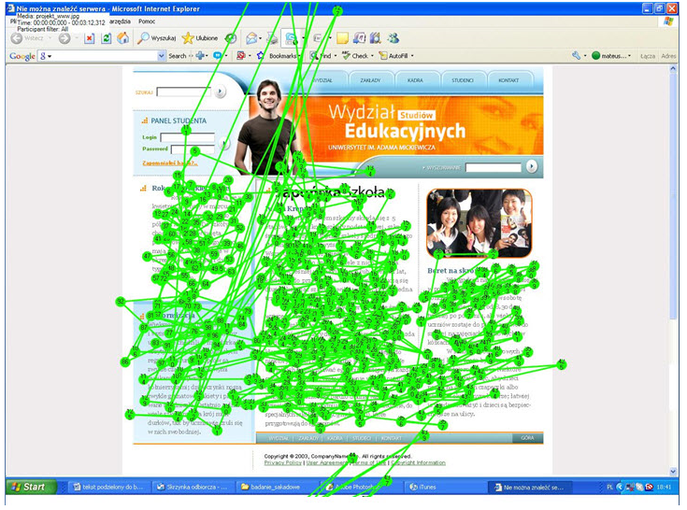
If, paradoxically, the informational content is based more on text, they don’t take it into consideration, they don’t read it. If there are uploaded images, links, audio / video / multimedia content, it will be much more exciting, even if in terms of value of information content it is perhaps worse quality than the previous one.
Moreover, they are extremely familiar with using technology and equivalent applications in day by day activities. For them, the video sites and photo sharing, but also applications like social networking and blogs /
micro blogs are daily destinations, whether they access them from the static devices such as desktop, or mobile devices such as laptops, PDAs, smart phones / cell phones with Internet access.
So, if we consider only those issues, a portrait of the current generation of students is summarized in the following figure:

Fig. 2. Student in Web 2.0 era
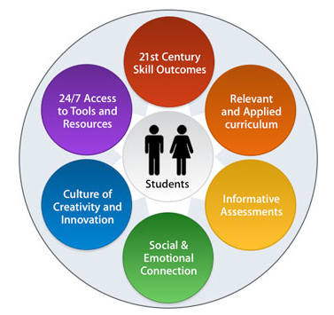
Source: http://ali.apple.com/acot2/principles/

Considering the above presented, it is clear that for these students, both teachers and the whole of society must prepare. Therefore, in accordance with the XXI century, every regional, national, European or world body tried to take measures to meet these new challenges generated by the new generation of young (but not only). Even the labour market is adapting, but for a future graduate this is not enough. Unfortunately, the current global economic crisis context may affect mostly the young graduates. For them, integration on the labour market in the coming years will be extremely difficult. Therefore, they also must take measures, to assimilate as much knowledge as they can, to acquire as many skills and competencies as they can, enabling them to show what they know, so that employers and / or recruitment agencies to observe and select them as potential candidates.
- Key competencies needed in career

According to “New skills for new jobs” report education, training and jobs are inseparable – there is a relation of interdependence between them. Moreover, each of them will have an ICT component, ubiquitous.Recognizing the importance of all the above, these components can be found across all strategies, policies or measures taken at European and world level by competent bodies.
Thus, at European level, we all know the 8 key components included in Lifelong Learning Strategy, including:
• Communication in the mother tongue
• Communication in foreign languages
• Basic skills in mathematics, science and technology
• Digital Skills
• Learning to learn
• Interpersonal, intercultural, civic or social skills
• Entrepreneurial skills
• Skills for cultural expression
From the perspective of UNESCO, skills and competencies are gathered around the following components:
• Learning to know
• Learning to do
• Learning to live together
• Learning to be
In view of UNICEF, skills and competencies are gathered around the following elements inclusive:
• Interpersonal Communication
• Decision making and critical thinking
• Self-organization and management
According to OECD point of view, skills and key competencies are identified as:
• Using various interactive tools
• Language, symbols, texts, knowledge, information, technology
• to interact in heterogeneous groups
• to interact independently:
• to structure life plans (projects, resources evaluation, to set priorities, to monitor the progress, etc.).
In our vision, the 21stCenturySkills project, undertaken in the U.S., manages to squeeze better the key competencies necessary for one person in order to be effective and competitive in this century: they are presented in the following figure:

Fig. 3. Student in Web 2.0 era
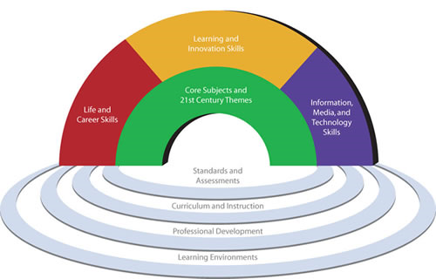
Source: http://www.p21.org

and detailed below:
• Skills for life and career
• Flexibility and adaptability
• Initiative and self-targeting
• Social and cross-cultural skills
• Productivity, Coordination & project management and responsibility
• Skills for learning and innovation
• Creativity and Innovation
• Critical thinking and problem solving
• Communication & collaboration
• Digital skills and competences
• Media, ICT and computer skills
Regardless to which of them we bow and the name of them, we can see that these skills and competencies refer both to the communications and to the networking or information. In addition, there can be observed other skills, as developing critical thinking, problem solving opportunity, innovation and creativity, flexibility and adaptability or productivity and entrepreneurship spirit.

- L@jost project

L@jost project – “Learn about finding jobs from digital storytelling” involves a partnership between 6 European countries: Romania (Romanian Institute for Adult Education - IREA), France (European Institute for eLearning), Germany (University of Duisburg Essen and the Institute for Innovation in Learning), Denmark (Danish School of Education), Italy (University of Florence) and Spain (Association Documenta) and is funded through Lifelong Learning Programme - Grundtvig action.
Beginning in December 2008, L@jost is to be completed in late 2010, this project aimed to bring together students, graduates and employers in an online social community, so that those who now have a job to facilitate the access on the labour market for those who still don’t work, giving them tips, and employers to freely express their expectations from the graduates in order to facilitate an informal environment for communication between students and employers.
Overall project objective is to stimulate the use of digital stories and ePortofolios among future graduates, in order to facilitate them insertion on the labour market. To achieve the project objectives, the consortium was based on expertise in various areas: ICT, adult education, workforce, training and teaching methodologies, European project management, dissemination strategies, etc., but also on a transnational research in partners’ countries involved in the project.
Thus, over 60 companies in Europe have responded to questions like: what is important for decision of hiring graduates, where vacancies are published, how do you identify graduates’ skills, importance of previous work experience, etc.
German companies recommended that the application documents (resumes, letters of intent) contain more information about the candidates and they should pay particular attention to the compliance between job requirements and their experiences. Applicants must be well prepared for interviews and to express their preference for work time. Skills as flexibility and openness are very important. The future employees should be highly qualified and to get as much work experience.
Romanian employers said that the job aspirants in their companies should be aware of the difficulties they will face while working, to be well prepared in the required field of expertise and have a very nice attitude to any work colleague. The candidates should know them weak and strong points. He/she should try to acquire more information about the work place and the position which he/she thinks is fitting better. It also should be given special attention in developing the desired competencies and to the horizons’ broadening. Applicants should prepare for each interview and submit applications as much as they can, in order to increase their chances of finding a job.
In Denmark, employers have proposed a real work to the applications, which should be justified and addressed to a specific job in the company. These must include, in addition to a resume, copies of certificates from various courses. Candidates must know information about that company where they want to work. In the domain of consultancy services, it is recommended to attach letters of recommendation, along with letter of intent and resume. In Denmark, personal contacts are very important. The applications will be carried personally, so that potential future colleagues should know you. Also, sending an application, without having been previously announced a vacancy, could be an effective way to be hired. This action requires a bit of courage, and is typically found in consulting companies.
A candidate must have clear expectations and future plans – it is the opinion of Italian employers. This should seek to gain professional experience before entering on the labour market. For a private company is very important to know and be sure that those interested in a job within their companies can respond to future challenges. This is why fewer specialised candidates are often chosen because they are flexible and can perform various tasks. In addition, applicants should begin developing their own networks.
The employers from Spain highlighted the importance of education and desire for lifelong learning. The request application must be adapted to the company profile and vacancy. In addition, well-defined interests, and an accurate selection of vacancies could support graduates in their job search.
In France, the employers focus on proactive future employees and urge them to believe in the company which offers a job. Applicants must demonstrate that they are satisfied with their job and should not be willing to ask for more. The request application must always be tailored to vacancies and the company.
More details about the research report, but also about the project can be obtained from its website, http://lajost.eu, whose homepage can be viewed in the image below:

Fig. 4. Screen capture from L@jost project website 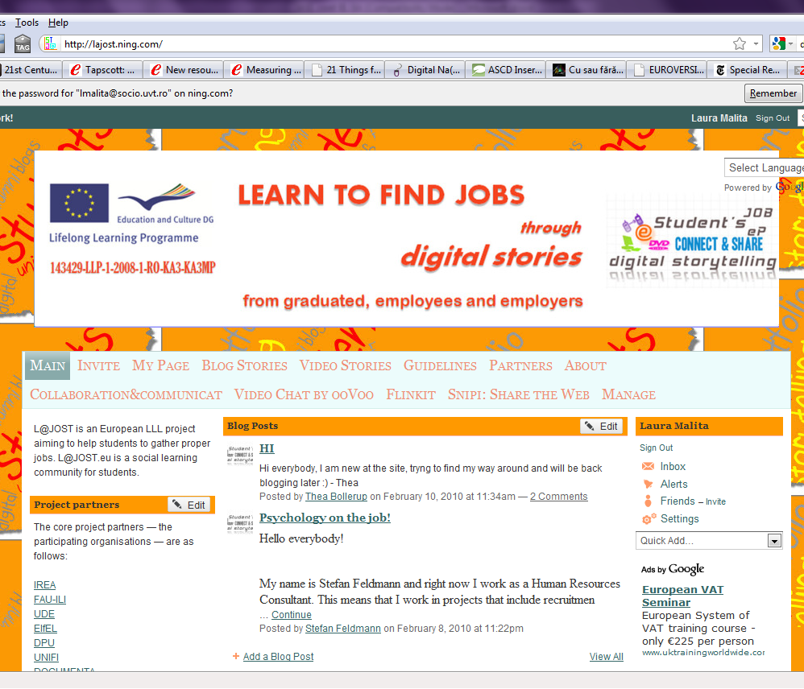
Source: http://lajost.eu

- Conclusions

Taking into consideration the skills and competencies presented above, but also the L@jost project description, we can observe that beyond the skills and competencies that would be well reflected in the CVs of candidates, it's good that they use other advantages, too, in order to show they know what they know. Thus, activating in the project’s social community, participants will also develop other informal skills: to communicate in a foreign language, to question, to reflect and have a critical thinking relative to a specific situation, computer skills specific to Web 2.0 applications etc. Moreover, they learn from others experience, they learn from their actions or what they found out.
Thus, because an employer / recruitment agency use today additional methods to select potential candidates, to learn more about him beyond what is contained in the resumes, skills and competencies mentioned above should be highlighted in a better way. It is important that this project to provide practical support (examples of good practice) which can count on finding a job, according to the skills and competencies the graduates have.

- REFERENCES

Maliţa L, Martin C., 2010, Digital Storytelling as Web Passport to Success in the 21st Century, WCES 2010
Maliţa L., 2009. “E-portfolios in an educational and occupational context”, in Procedia – Social and Behavioral Sciences, 1(1), p. 2312-2316.
OECD, 2005, The definition and selection of key competencies: http://www.oecd.org/dataoecd/47/61/35070367.pdf
UNICEF, Which are life skills? http://www.unicef.org/lifeskills/index_whichskills.html
UNESCO, Learning the treasure within, http://unesdoc.unesco.org/images/0010/001095/109590Eo.pdf
Recommendation of the European Parliament and of the Council on key competences for lifelong learning, 2005, http://ec.europa.eu/education/policies/2010/doc/keyrec_en.pdf
The Partnership for 21st Century Skills, Framework for 21st Century Learning, http://www.p21.org

The Romanian Institute for Adult Education, Timisoara www.irea.uvt.ro, The Department of Modern Languages and Social Informatics, Faculty of Sociology and Psychology, West University of Timisoara. E-mail: lmalita@socio.uvt.ro
The Romanian Institute for Adult Education, Timisoara. E-mail: catalin.martin@irea.uvt.ro

